Member ID: ____________________
Time: ___________________
Rank: _______________



Integrated Office Applications
(215)

NATIONAL 2024

PRODUCTION
Job 1: Spreadsheet __________ (230 points)
Job 2: Database __________ (250 points)
Job 3: Letter __________ (100 points)
Job 4: Database/Mail Merge __________ (100 points)
TOTAL POINTS __________ (680 points)

Industry Certification (50 minutes)
MOS PowerPoint Associate Certification
Test Time: 90 minutes

GENERAL GUIDELINES:
Failure to adhere to any of the following rules will result in disqualification:
- Member must hand in this test booklet and all printouts if any. Failure to do so will result in disqualification.
- No equipment, supplies, or materials other than those specified for this event are allowed in the testing area. No previous BPA tests and/or sample tests (handwritten, photocopied, or keyed) are allowed in the testing area.
- Electronic devices will be monitored according to ACT standards.

EXAM GUIDELINES:
- Ensure this test booklet contains Jobs 1-4.
- Key all jobs according to the instructions given.
- Correct any and all formatting, spelling or grammar errors. Use the formatting guide in the Style & Reference Manual.
- Your name or initials should not appear on any work you submit. Use your Member ID in any occasion you would normally key your reference initials.
- In the lower right-hand corner of ALL work submitted (unless otherwise specified), key your Member ID and job number.
- If you complete the event before the end of the time allotted, notify the proctor. Time may be considered a factor in determining a winner when there is a tie score.
- Place your scoring sheet on top of your jobs. Jobs should be placed in numerical order.
PART ONE Instructions: Production
Once you have completed all four jobs listed below, upload all competition materials (including project files, etc.) to the National BPA Pre-submit System at presubmit.bpa.org.
PRODUCTION STANDARDS
0 Errors | 100 Points
1 Error | 90 Points
2 Errors | 70 Points
3 Errors | 50 Points
4+ Errors | 0 Points

IOA-Job1-MemberID.pdf
IOA-Job2-MemberID.pdf
IOA-Job3-MemberID.pdf
IOA-Job4-MemberID.pdf

PART TWO Instructions: This exam requires the MOS PowerPoint Associate Certification. Please do not leave your seat or exit the room until you have completed the certification. After the certification has been administered, you are permitted to leave.
Job 1 - Spreadsheet | Possible Points | Points  Awarded
Data input correctly (follows production standards)  0 errors – 100 points, 1 error – 90 points, 2 errors – 70 points, 3 errors – 50 points, 4+ errors – 0 points | 100
Autofit all columns to contents | 5
All information in Row 1 Bold | 5
Use a VLOOKUP formula using the information in columns J & K to return the correct base salary for each position | 20
Calculate 401k match column. 5.5% of base salary | 5
Enter 12,375 for all positions for Health Insurance | 5
Enter 5,450 for all positions for Life Insurance | 5
Calculate total benefit package | 5
Format information in columns D:G number with Comma style, 0 decimals | 5
Format column H as Accounting number format, 0 decimals | 5
Calculate totals for columns D:H in row 45 as Accounting number format, 0 decimals, Bold | 5
Member ID# and Job# in right footer | 5
Print in Landscape orientation (fit to one page if needed), with gridlines | 10
Print w/formulas
Landscape, gridlines, fit to one page, A1:H45 only | 5
VLOOKUP formula correct | 25
401k match formula correct | 10
Total Benefit package column formula correct | 5
Total Formulas in Row 45 correct | 5
Job 1 Total | 230
Job 2 - Database
Query
Query contains Department, Position, Base Salary, and 401k match fields | 20
Information Technology and Human Resources Departments only | 15
Sorted by Position, alphabetic order | 5
All information is visible | 5
Query Name is correct with Member # | 5
Job 2 Query Printout 1 | 50
Create report Named Information Technology and Human Resources Departments using all fields in the query | 10
Group by department | 10
Alphabetize by position, ascending | 10
Add Avg summary options for base salary and 401k match | 5
Stepped layout, Portrait orientation | 5
Member # is subheading underneath report name | 5
All labels/information are visible | 5
Eliminate summary data in department footer | 5
Change Avg label to Average | 5
Change 401k average to Sum, Add label ‘Total 401k Match’ under Average | 10
Align average and total numbers with columns they represent | 10
Bold, italicize total/average labels and amounts | 10
Change total/average amounts to currency format, 0 decimals | 10
Job 2 Report Printout 2 | 100
Job 2 Total | 150
Job 3 – Letter (this will be printed in Job 4)
Production Standards  0 errors – 100 points, 1 error – 90 points, 2 errors – 70 points, 3 errors – 50 points, 4+ errors – 0 points | 100
Job 3 Total | 100
Job 4 – Database/Mail Merge
Data input correctly (follows production standards)  0 errors – 50 points, 1 error – 45 points, 2 errors – 35 points, 3 errors – 25 points, 4+ errors – 0 points | 50
Database printout, 1 page, landscape, all information visible | 20
Printout of letter with Merged Codes | 20
Printout of Kerry O’Connor letter | 10
Job 4 Total | 100
TOTAL | 680

Job 1: Spreadsheet

You have been hired as an Information Processing Assistant in the Information Technology department of Digital Solutions. Your supervisor, Tom Carlson, would like you to prepare several different documents.

- Please create a spreadsheet and enter the information below:

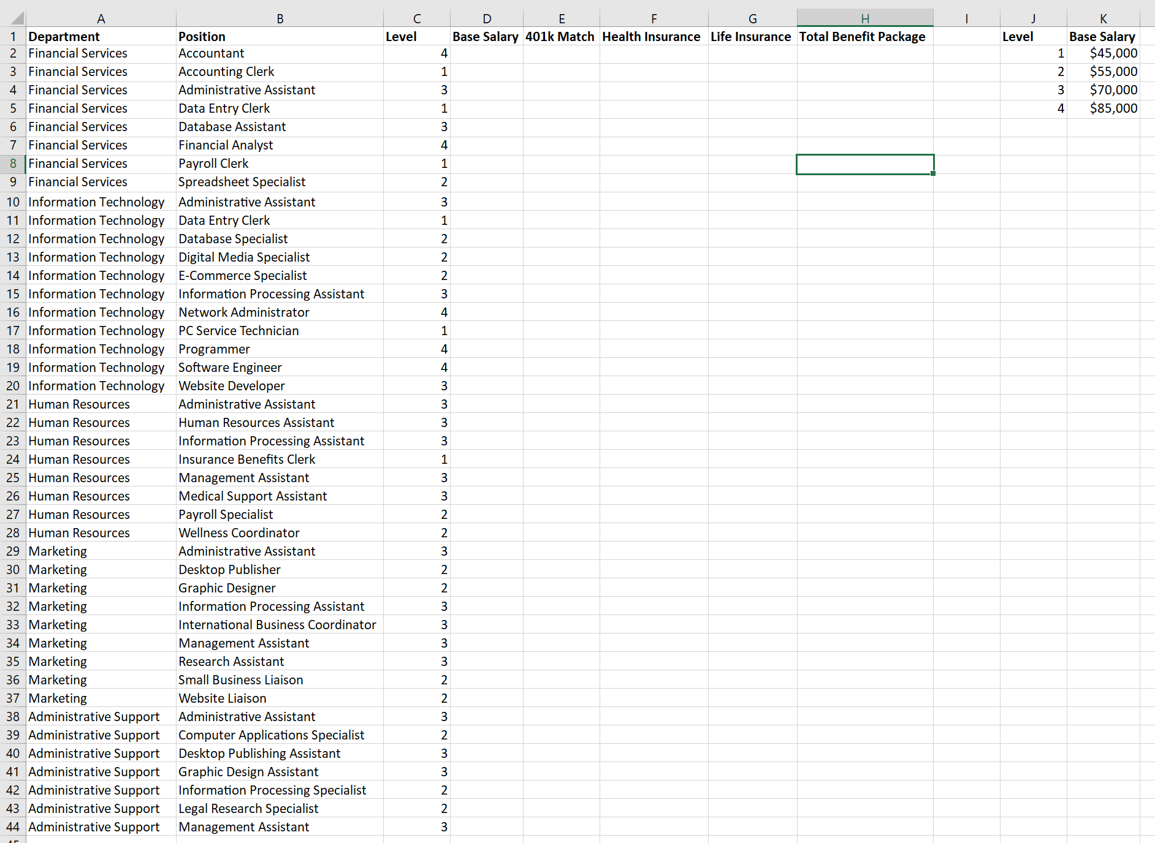

- Autofit all columns to their contents.
- Bold information in Row 1.
- Use a VLOOKUP formula using the information in columns J & K to return the correct base salary for each position.
- Calculate 401k match column. 5.5% of base salary.
- Enter 12,375 for all positions for Health Insurance.
- Enter 5,450 for all positions for Life Insurance.
- Calculate total benefit package by adding all information in columns D-G.
- Format information in columns D:G number with Comma style, 0 decimals.
- Format column H as Accounting number format, 0 decimals.
- Calculate totals for columns D:H in row 45 as Accounting number format, 0 decimals, Bold.
- Put your Member ID# and Job# in the right footer.
- Print in this in Landscape orientation (fit to one page if needed), with gridlines.
- Print again w/formulas showing in Landscape, gridlines, fit to one page, A1:H45 only.

Job 2: Database

Mr. Carlson would like you to create a database using information in the spreadsheet that you created in Job 1.

- Import your information from Job 1 into a database named Job 2. Accept all the defaults, except do not have a primary key. Name the table Imported Information.
- Since you will not need all the information, delete columns 9,10,11. You will only need information through the Total Benefit Column.
- Delete the row/record at the bottom that contains the column totals.
- Create a query from the Imported Information Table including only Department, Position, Base Salary, and 401k match for the Information Technology and Human Resources departments, sorted ascending by position.
- Make sure all information is visible.
- Name the query IT and HR Query—Member #
- Print the query.
- Use the IT and HR Query to create a report named Information Technology and Human Resources Departments. Use all fields. Group by Department. Alphabetize by position ascending. Add Avg summary options for base salary and 401k match. Use a stepped layout in portrait orientation.
- Add your Member # as a subheading underneath the report name.
- Adjust Column labels to show all information.
- Eliminate the summary data in the department footer.
- Change Avg label to Average.
- Change 401k average to a total for that column and add a label ‘Total 401k Match’ underneath Average.
- Align the average and total numbers under the columns they represent.
- Bold and Italicize the total and average labels/amounts. Change them to currency format with 0 decimal places.
- Print the report.

Job 3: Letter

Key the following letter using your Style & Reference Manual. Correct any spelling and punctuation errors you find.

Do not print this letter until you complete Job 4 inserting the field codes where appropriate. Use the first name as the field on the salutation line. Provide the appropriate salutation. It is from Julie Smith, Human Resources Department Manager. Use today’s date, the head of the financial services department should be copied, and apply an appropriate subject.

Body of letter

Welcome to Digital Solutions. Your official title is <Position>

Please make sure you complete all of the enclosed IT and health insurance forms one week prior to your hire date of <hire date> as we need to make sure we have ample time to get your badge, email, log in and passwords created so you are ready to go on Day 1. You have been assigned <Mentor> as your mentor during your 3-month probationary period. Your mentor will be meeting with you from 10-11:30 a.m. on your first day.

If you have any questions prior to your hire date with your paperwork, please contact the Human Resources department 888-125-6512. Any other questions, please call our main number at 888-125-1000 our receptionist will be able to direct your call. We cannot wait to see you on <Hire Date>!

Job 4: Database

Create the table in the Job 2 database. Name the table New Hires—Member #.

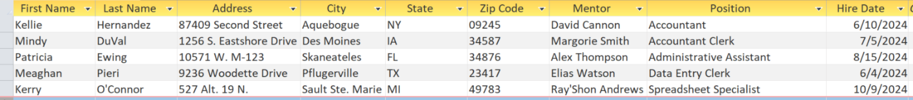

- Print the table adjusting the columns to fit to one page, landscape orientation.
- Use this table to merge with the letter in Job 3. Print letter for Kerry O’Connor only.
- Print a copy of the letter with the merge codes.

